Marina Manager Report:
Kristina Cummings
November 2025

Contracts / Payments for winter – 16 contracts not completed / $25,563.64 that is not on a payment plan or arrangement
2 boat that are supposed to be gone are still here without contracts as they have told me they are leaving

Still dealing with stray voltage on the docks in the upper harbor, we still have not received the report from O’Neil for this summer. We ordered an additional tester that give us more information on if it is the boat our system or the neighboring boat. We had an expert that came in and talked over why we have stray voltage and how it can happen

New electric rate $.21 per KWH
New natural gas rate $1.20 per therm
Shop – 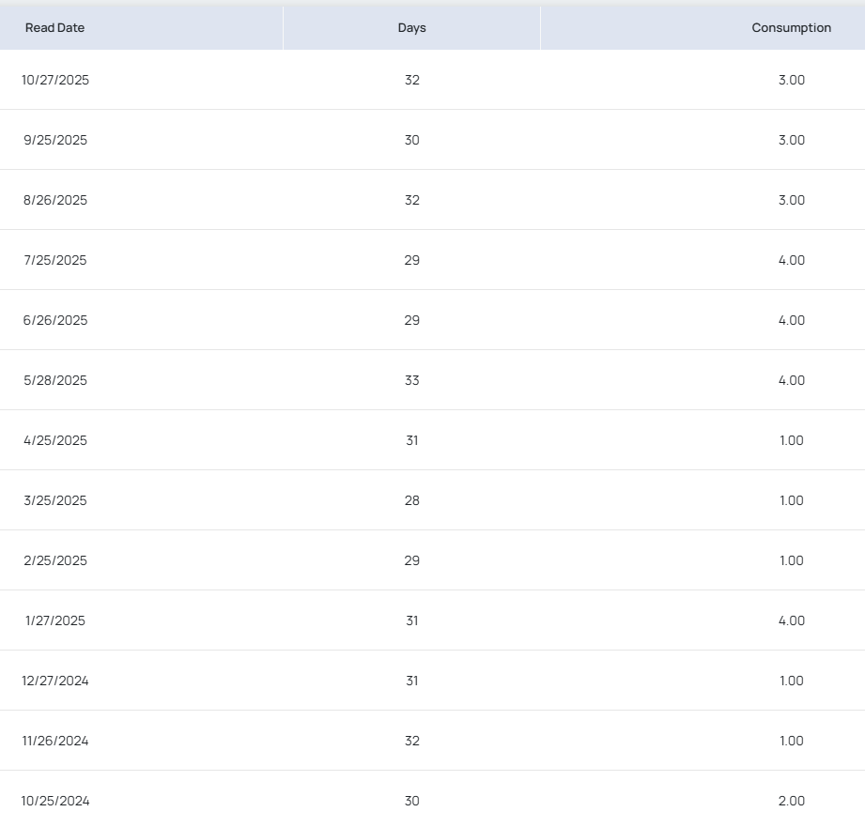

Clubhouse – 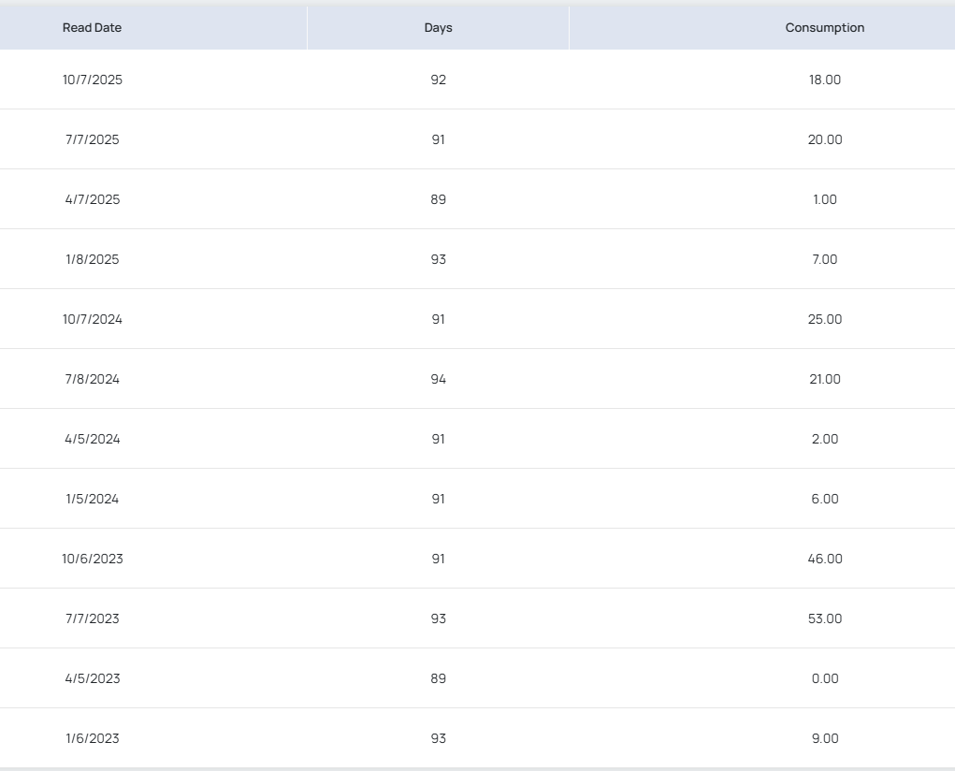
Upper Harbor – 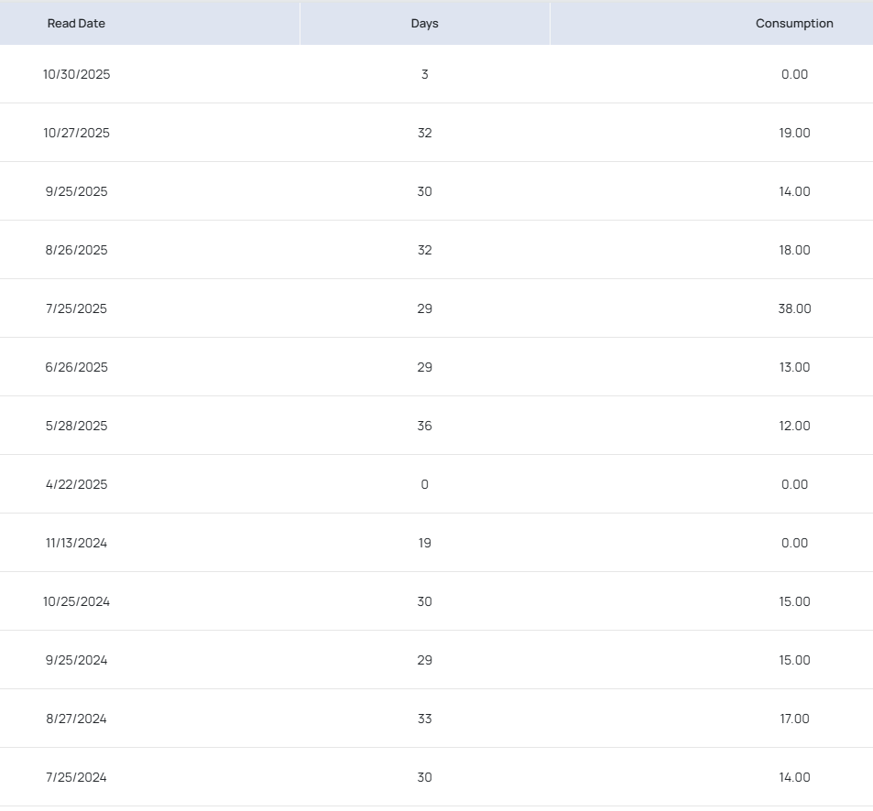

Lower Harbor – 